R-1 Launcher

R-1 Sounding rocket
Specifications and assembly instructions
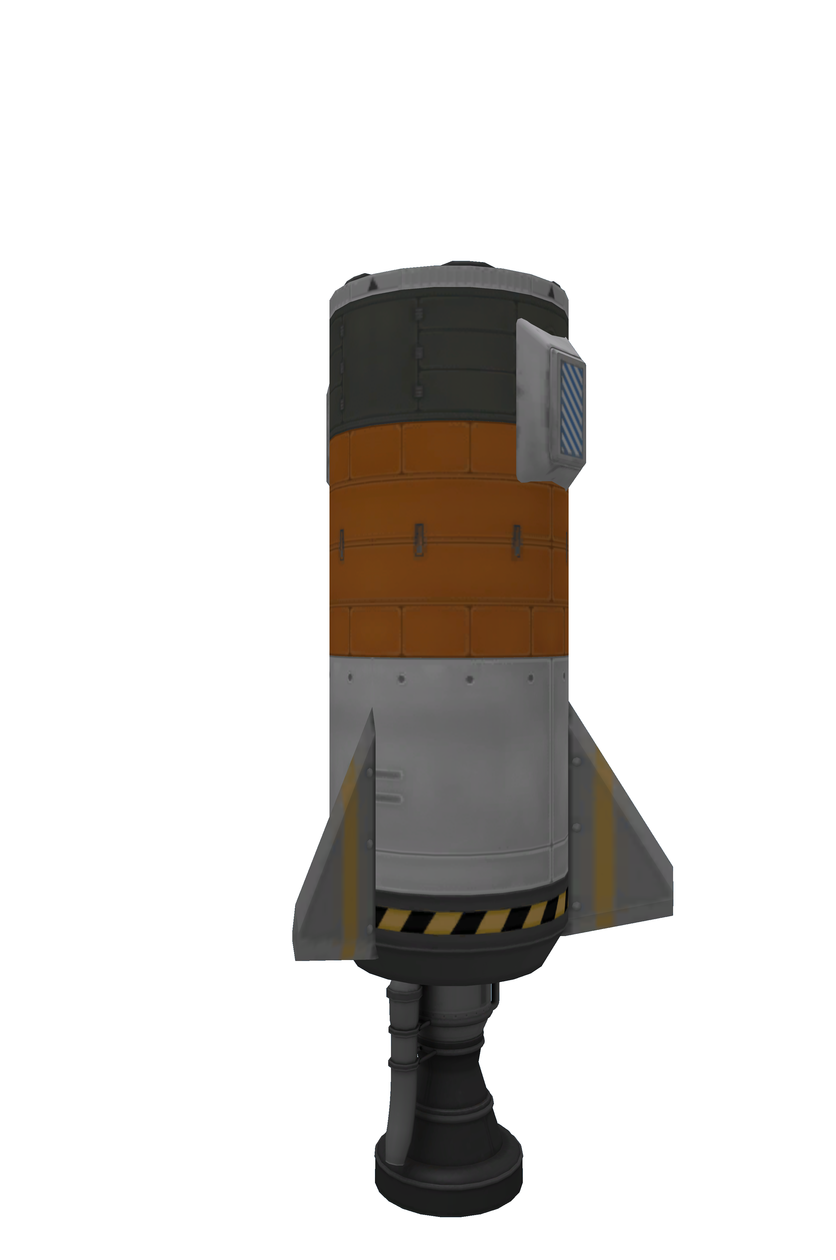

Description
The R-1 is an dumb, unitary, low tech, single stage, liquid fuelled sounding rocket. The rocket is designed to take a payload on top to the limits of Kerbin’s atmosphere.
The rocket has no flight computer and depends on command inputs from the payload. No guidance is available except for passive stabilisation provided by three small fins.
The rocket is suitable for launching small (125 cm) naked capsules like the Mk1.

Basic construction
The rocker is built in a single assembly operation and construction is straightforward. Only a single variant exists.

Assembly instructions

Parts list
1x LV-T30 "Reliant" Liquid Fuel Engine
2x FL-T200 Fuel Tank
1x FL-T100 Fuel Tank
3x Basic Fin
2x Mk2-R Radial-Mount Parachute
1x TD-12 Decoupler

Assembly procedure
- Start with Reliant engine
  - Position gas generator exhaust pointing to the west
- Connect T200 tank axially on top of engine
- Connect T200 tank axially on top of T200 tank
- Connect T100 tank axially on top of upper T200 tank
  - Use Dark ("black lines") pattern
- Connect decoupler axially on top of T100 tank
- Install fins radially on T400 tank
  - 3x symmetry with snap
  - Position W/NE/SE
  - As low as possible during fitting
  - Lower fin rivet should be positioned at the bottom of the engine shoud "warning pattern"
- Install parachutes axially on T100 tank
  - 2x symmetry with snap
  - Position N/S
  - Raise parachutes along rocket length until centre of parachute top intersects with bottom of upper line on T100 tank
- Repaint as desired
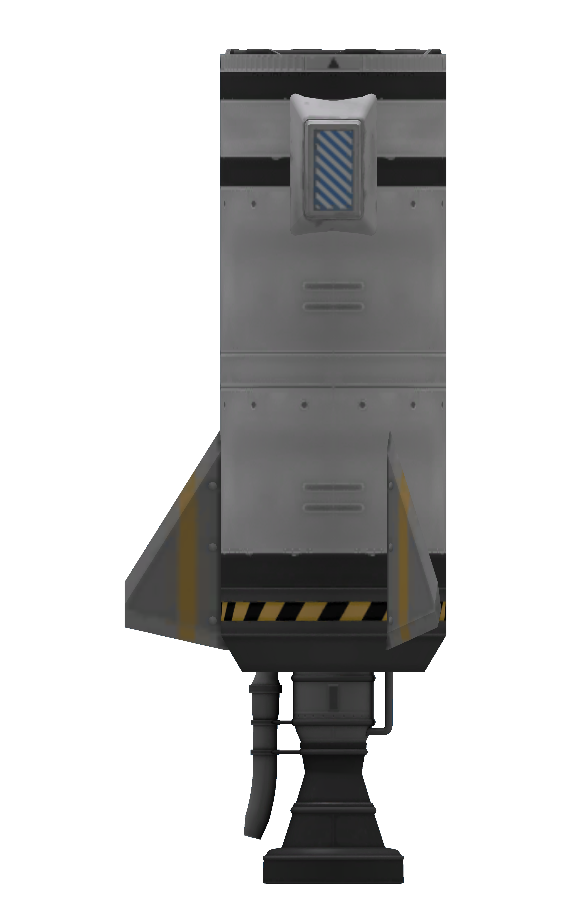Figure 1: Final assembled form of the R-1 rocket. Note parachute position relative to uppermost line painted in top tank.

Stage configuration
Part | Variable | Value | Default | Notes
Engine | Throttle | Main throttle | Yes
Engine | Thrust limiter | 100 | Yes
LFOX tank (lower) | Flow priority | +2 | Yes
LFOX tank (mid) | Flow priority | +1 | No
LFOX tank (upper) | Flow priority | 0 | No
Decoupler | Force percent | 100 | Yes
Decoupler | Enable crossfeed | False | Yes
Decoupler | Enable staging | True | Yes
Parachutes | Deploy mode | When safe | Yes
Parachutes | Min pressure | 0.6 | No
Parachutes | Altitude | 500 | No
Parachutes | Spread angle | 10 | No

Staging
Stage | Parts | Notes
0 | Parachutes, decoupler
1 | Engine

Post flight maintenance
- Decoupler
  - Enable staging
- Tanks
  - Fill

Pre flight checks
- Verify staging
- Verify parachute settings

